|  |
| --- |
| DewCIs Solutions Limited |
| Accounting System |
| Design Document |
|  |
| **patrick** |
| **9/14/2012** |

|  |
| --- |
| [Type the abstract of the document here. The abstract is typically a short summary of the contents of the document. Type the abstract of the document here. The abstract is typically a short summary of the contents of the document.] |

Contents

1.0 Abstract 2

2.0 Overall Description 2

2.1 System Description 2

2.2 Purpose of the project 2

Challenges of Manual System 2

2.3 Scope 2

2.4 Approach 2

2,5 Features Of the system 3

3.0 Users 3

3.1 Primary users 3

3.2 Secondary users 3

4.0 Systems Modules 3

4.1 Sales 4

4.2 Purchases 5

4.3 Procurement 6

4.3.1 Objectives 6

4.3.2 Details 6

4.4 Store management 10

4.4.1 Objectives 10

4.4.2 Inventory management 10

4.4.3 Asset management 11

5.0 Overall Interlink of modules 11

6.0 Development Schedule 11

# 

# Abstract

This Specification document describes an Accounting application that is to help business enterprises and organizations manage and keep track of theirs financial records. The purpose of this project is to create a maintainable accounting program that allows for easy user input, quick glance features of businesses/organizations current financial situation, and easy customization. It will allow users to graphically see where all expenses and incomes and provide sufficient information for good decision making.

# 2.0 Overall Description

### 2.1 System Description

A Sales and Marketing system is a collection of software modules that automate business tasks such as inventory control, sales processing, and tracking of customer interactions, as well as analyzing sales forecasts and performance

### 2.2 Purpose of the project

The main purpose of the project is to eliminate the manual system that has loop holes and is quite ineffective and error prone.

## Challenges of Manual System

* + Very complex and non repeatable lead/proposal qualification process
  + Difficulties in properly assigning resources to prospects and even harder to take stock of resource distribution/apportionment
  + Hard and sometimes impossible to keep track of the sales cycle and identify bottlenecks
  + Too much activity which cannot be tracked and someone held accountable
  + Very subjective sales/marketing staff performance appraisal due to lack of enough/relevant information that is required to inject objectivity into the process

### 2.3 Scope

This project will be created in releases. The first release will contain the basic functionality. The second and subsequent releases will contain extra features useful in accounting processes. The system will basically cover four modules in accounting, which basically include sales, purchases/procurement and store management.

### 2.4 Approach

The approach used to counter the challenge of the manual system may be countered using the following.

* + Put in place checklists that will be used to qualify specific leads and products
  + Provide facility to assign resources to tasks, and workflows and identify responsible person(s).
  + Put in place a workflow mechanism to keep track of exchanges and communications throughout the accounting cycle(s) e.g sales.
  + Provide user friendly and intuitive reports that will assist the users in analyzing the trends and performance of the employees and the organization in general

### 2,5 Features Of the system

The system will have the following features.

* General ledger based
* Entry by classified journals
* User defined chart of accounts
* Departmental categorization
* Project Clustering
* Department based Expenditure budgets
* Department based Revenue budgets
* A centralized database that will allow concurrent access of those who enter data and those who want to view the entered data.
* Ability to accesses remotely to enable unlimited use of the system even to those who aren’t in urban areas.
* Strong security features to ensure data and information is not corrupted accidentally or maliciously.

# 3.0 Users

### 3.1 Primary users

* Managers: - To enter the basic details of the system eg sales workers, departments, suppliers etc. They may also view reports, create budgets etc
* Sales Persons: - To enter details of the sales made.
* Procurement Personnel: - To enter the details of the items to be procured and those procured.
* Auditors: - To view and audit the entries that have been entered.

### 3.2 Secondary users

* Maintainer: - This user will be working on the code and keeping the program working. This user will also be the one responsible for implementing new features. For this person the code must be easy to maintain and update.

# 

# 4.0 Systems Modules

**Accounting**

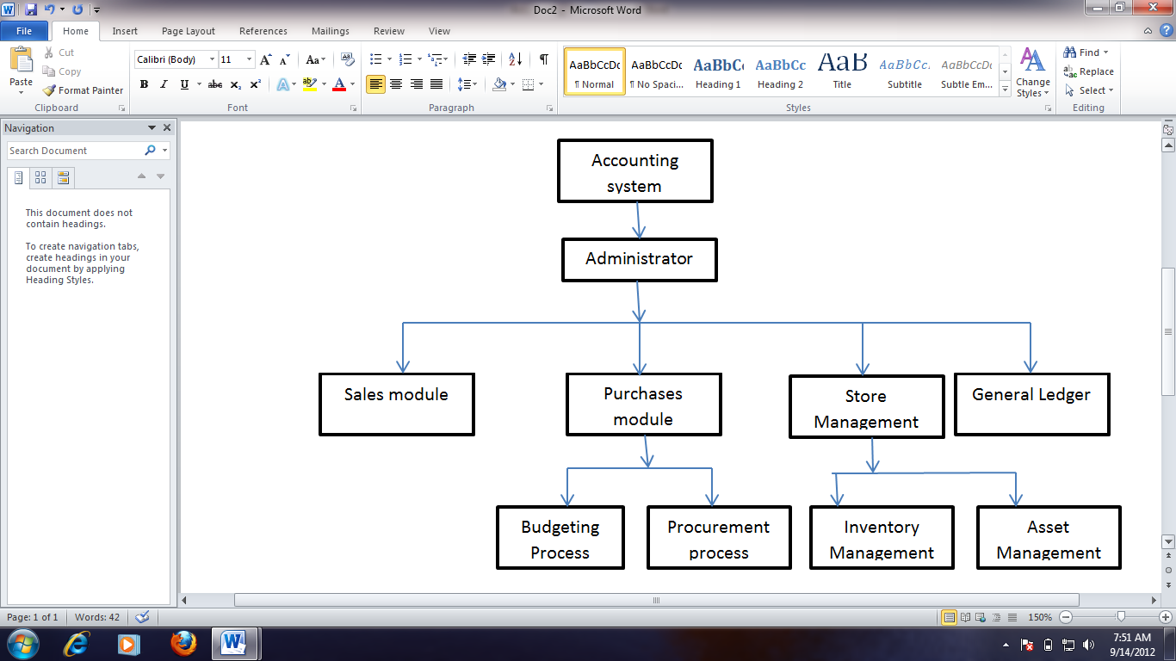

This will basically cover the basic process of identifying, measuring and communicating economic information to permit informed judgments and decisions by users of the information. The main objectives of this module will be letting people and organizations know

* If they are making a profit or a loss
* What their business is worth
* What a transactions was worth to them
* The amount of cash they have
* How much they owe others.
* How much they are owned by others.
* Records to check what they do.

To support above objectives the system will have the following supportive modules

## 4.1 Sales

In this module the system will cover the basic procedures of selling goods or services the business of organizations is dealing with. This will entail both credit and cash sales. The main objectives met by this module are

Allow entries of sales made to customers who will already be registered in the system

* Indicate the number of sales that have been made.
* Indicate both cash and credit sales.
* Show sales returned by our customers.
* Show the basic reporting of sales.

#### Process

The system will allow purchase orders from the various clients and process the purchase orders.

The system will also allow registration of new customers if they are non existing in the database.

Payments made will be entered In the system which also supports credit sales and management of credit from the various customers. Relevant reports will be produced to show which clients own the business or organization.

The system will also allow reconciliation of sales indicating whether profit or loss has been made. In addition to these issues concerning sales will be made including sales returns.

The diagrams below show the general sales process

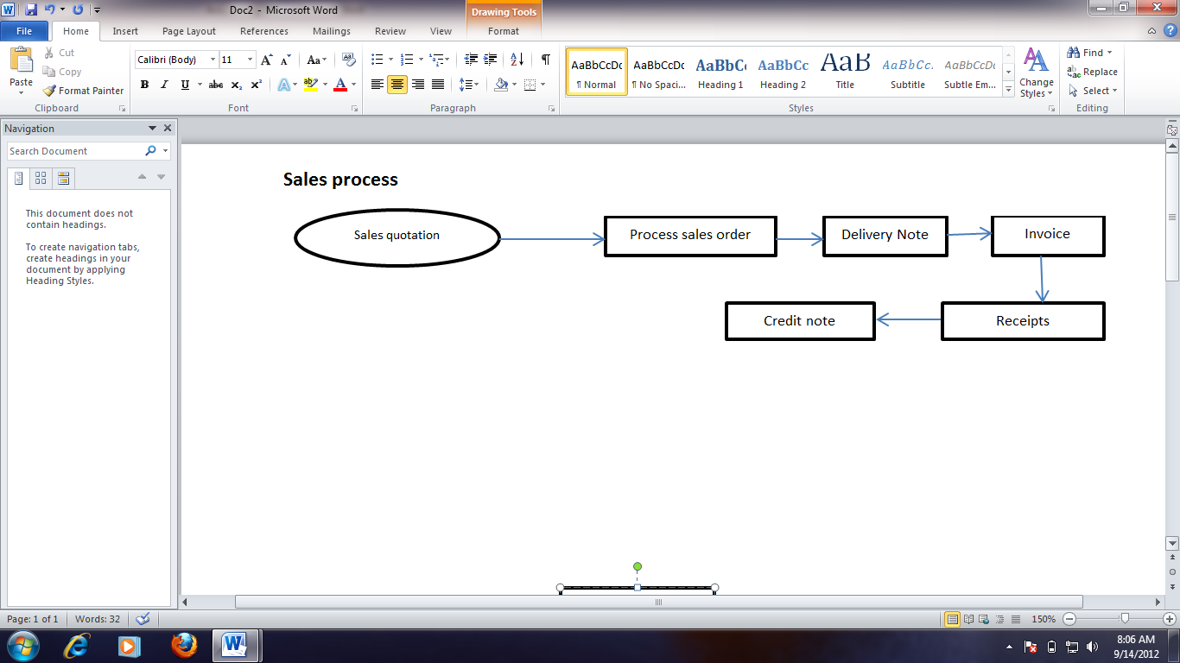

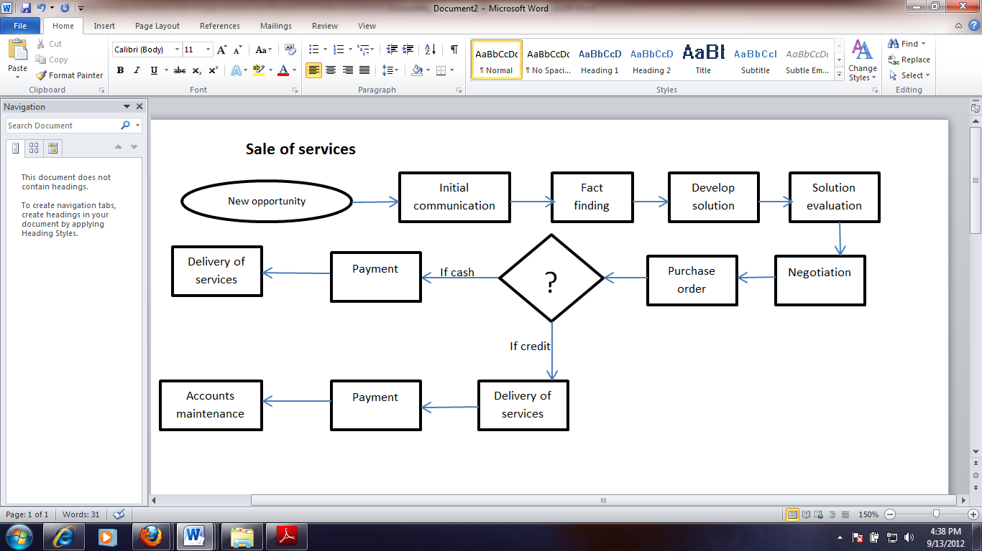

## 4.2 Purchases

The main objectives of this module will be:-

* Ensure the process of purchasing goods is clearly followed by the respective personnel.
* Allow entries of purchases make by the organizations for resale.
* Allow entries of purchases returned/return outwards by the organization.
* Produce the required reports.

## 4.3 Procurement

### 4.3.1 Objectives

* Allow the budgeting for the items to be procured by the organizations departments and as a whole.
* Ensure the budget creation process follows the right produce/tendering process.
* Allow entries of purchases of items to be consumed by the organizations.
* Produce the relevant reports.

### 4.3.2 Details

Procurement Management entails the activity of handling request of required goods to the moment of arrival and payment of the goods. Online procurement plan are negated from the budget and the cash management system based on defined authorization levels. Raise requisitions for items that must be in the procurement plan. The requisitions are automatic conversed to order ready for processing after the defined approval process. The system also supports processing of purchase orders based on contractual agreements with a supplier, specifying payment terms, delivery dates, item identification and quantities. Management of goods receipt also including support of partial delivery and goods returns.

The system automatic links the received goods to the warehouse and storage bins supported with alerts on reorder levels. There is a seamless integration of purchase orders and goods receipt notes to the purchase invoice and an automatic audit of document flow from Requisition > Purchase order > Goods receipt note > Purchase Invoice and payment flow.



The procurement system involved the following automated process.

* Departments fill out a Purchase Requisition which is automatically matched against the budget.
* The Requisition undergoes all necessary approvals and check.
* The Purchasing Office approves all requisition received from departments then an LPO is prepared for each item in the requisition.
* All LPOs appear in the Business Office online window for further approval.
* Approved
* If approved, the LPO is then sent to the suppliers as an order form from the purchasing office.
* As agreed on the LPO, payment for the items delivered are paid and delivered.
* Support for automated contract creation, management, and reporting.

**Primary Data**

1. Enter details all suppliers, including their banking details and product categories supplied.
2. Track supplier deletion and data changes
3. Create a customized items category
4. Enter details of all items for purchase

**Purchase Requisition**

These forms are used by the various departments that constitute the college to make purchases from outside facilities or departments. Each PRF would need approval from the Department Head, School Dean.

**Raise requests to quote online**

The system generates online quotation in excel format that allow for suppliers to fill in costs and return the document for upload to the system. Support for Electronic purchasing via Electronic Data Interchange EDI standards, order and invoice transfer, invoice receipting and automatic invoice matching.

**L.P.O.**

The LPO is a detailed description of the terms of sale between the supplier and the organization clearly stating the payment details, authorization, item(s) to be delivered, who was spoken to, date and the quotation given; also if a fax was sent and where to. It should have various departments to which the report is sent to when the LPO is completed; the suppliers, Accounts Office, Procurement Office and the requesting department.

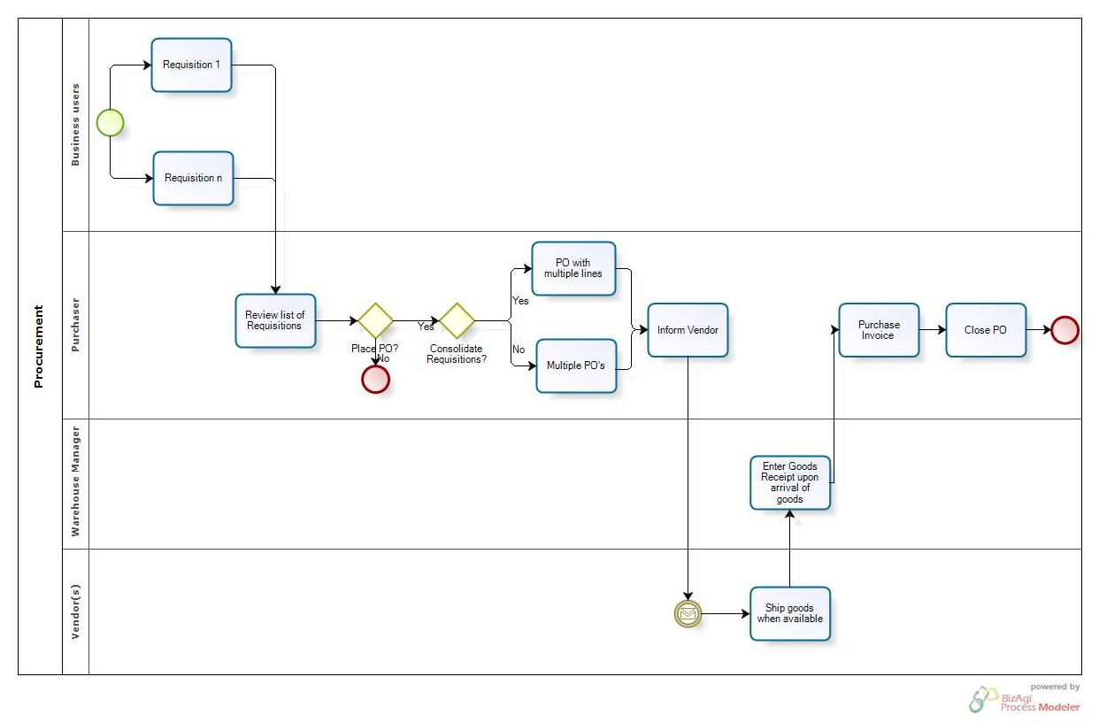

**Order Processing**

System involves tracking of the LPO forms and automatically generating reports which would include within the report anyone who has accessed or checked on the progress of the LPO. This is due to the high security that would have to be around the LPO. Only senior employees in the relevant departments of the college would be allowed to access the LPO. System will also keep the past purchasing records of the department which will help ensure that it stays within its budget and more accurately .This would also ensure that the various departments do not repeatedly order the same things over and over again.

**Receive goods**

1. Receive stock either by LPO or by cash purchase.
2. Enter of delivery notes and invoices.
3. Generate a GRN for each procurement transaction.
4. Record if goods were inspected, when and by whom.
5. Make relevant ledger postings after formal acceptance of supplies.
6. Handle partial deliveries and goods returned

## 4.4 Store management

### 4.4.1 Objectives

* Allow new entries of items to the stores and uniquely identify them
* Track the movement of the items in and out of the store.
* Keep record of items to be disposed on wearing out.

### 4.4.2 Inventory management

The Inventory Management module keeps a detailed accounting of inventory quantities, and at the same time, provides in-depth information to help you make purchasing and pricing decisions. The system which can be integrated with the procurement makes it easier to eliminate possible errors.

This helps in Comprehensive reports provide up-to-date information on stock status, reordering needs, inventory valuation, inventory turnover, and detailed item history and analysis.

The system helps supports Multiple Stores with an assigned code, description, address and general segment this achieved over the web.

1. On receiving stock, the systems automatically increment the stock level. On issuing out stock, the system reduces the stock level.
2. Generate material issue notes against an approved stores requisition.
3. Record which employees were allocated with specific items.
4. Track an item online
5. Valuation of stock from an accounting perspective;
6. Recognition of expiration dates where relevant;
7. Barcode scanning support;
8. Multiple stores and multiple locations within a store.

**Reporting**

The system is able to generate the following reports:

1. Pending and approved requisition
2. Produce a list of procurement requisitions made over a particular period.
3. Issued, pending and canceled LPOs.
4. Goods received against an LPO
5. Invoices issued against a good received note and LPO
6. Print drill-down report for goods, suppliers, department and other definable criteria

### 4.4.3 Asset management

Purchase of assets undergoes the normal procurement process and on goods receipt, assets are logged into the asset register. The asset can be transferred in different stores and departments. The system support the following asset features:

This will help in accurate accounting, acquisition, movement and disposition of property

1. Asset coding;
2. Depreciation / revaluation;
3. Location tracking;
4. Service schedules;
5. Maintenance details (incidents and costs);
6. Disposal records;
7. Handling of intangible assets, e.g. computer software.
8. Physical inventory process
9. Maintain up to date property records and initiate all forms necessary to properly carry out its function with respect to property and equipment.
10. Establish procedures and controls to protect property from loss, theft, abuse, or misuse.

# 5.0 Overall Interlink of modules

The accounting system is a one system in all as indicated below.

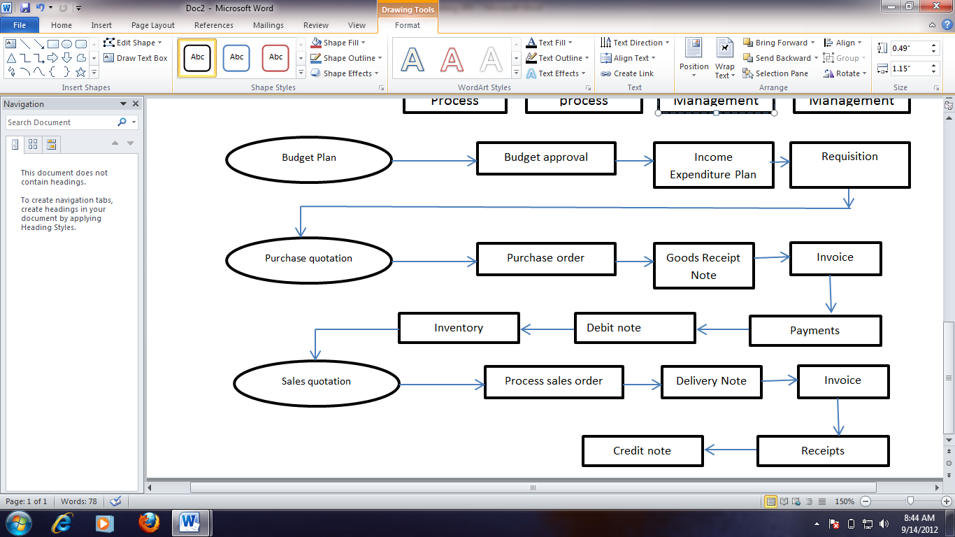

# 6.0 Development Schedule

|  |  |
| --- | --- |
| Time | Milestone |
|  |  |
|  |  |
|  |  |
|  |  |